|  |  |  |  |
| --- | --- | --- | --- |
| **Name of Student: NINAD AVINASH PATIL** | | | |
| **Roll No: 33** | | **Lab Practical Number: 1.3** | |
| **Title of Lab Practical: Write a windows application to demonstrate string functions like Reverse(), Sort(), BinarySearch(), Copy(), IndexOf(), LastIndexOf().** | | | |
| **DOP: 17/02/2021** | | **DOS: 24/02/2021** | |
| **CO Mapped: CO1** | **PO Mapped: PO3, PO5, PO7,**  **PO12, PSO1, PSO2** | **Faculty Signature:** | **Marks:** |

**Practical No 1.3**

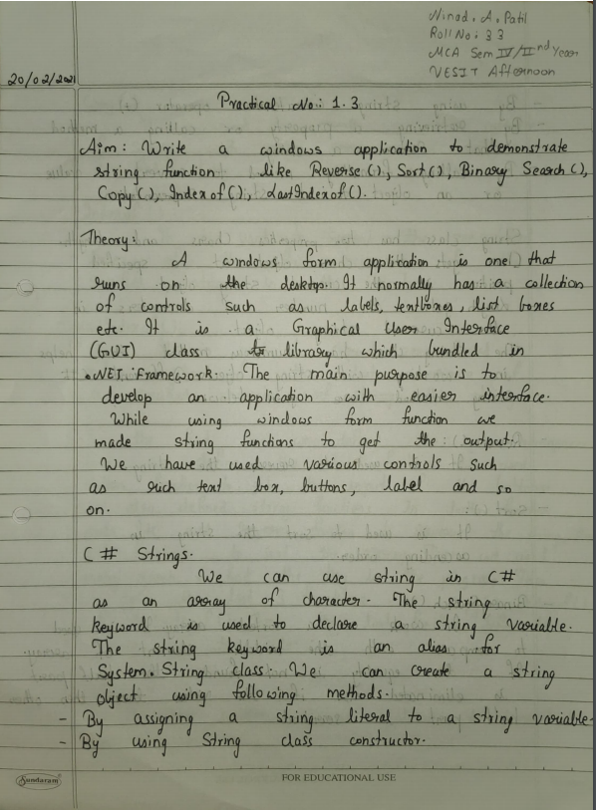

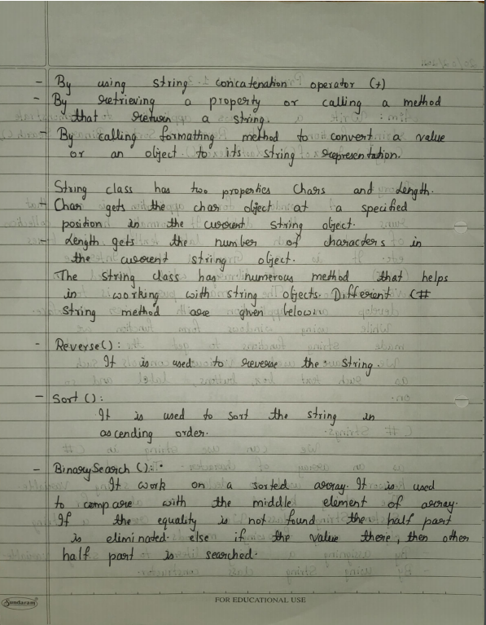

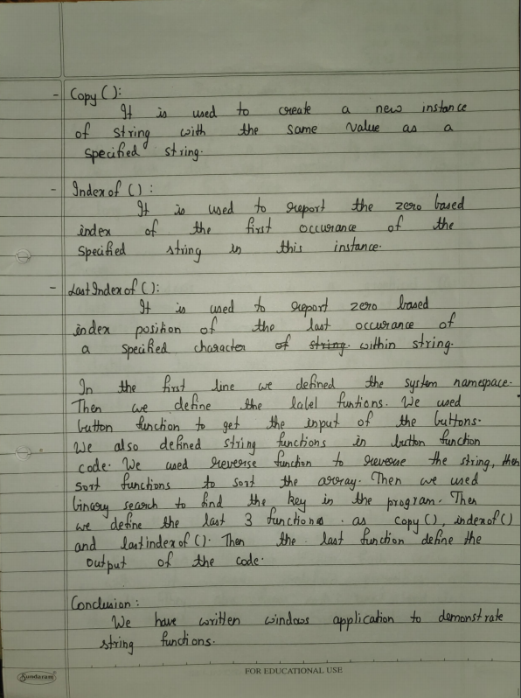

**Code:**

using System;

using System.Collections.Generic;

using System.ComponentModel;

using System.Data;

using System.Drawing;

using System.Linq;

using System.Text;

using System.Windows.Forms;

namespace WindowsFormsApplication3

{

public partial class Form1 : Form

{

public Form1()

{

InitializeComponent();

}

private void label1_Click(object sender, EventArgs e)

{

}

private void button1_Click(object sender, EventArgs e)

{

var = richTextBox1.Text;

char[] arr = var.ToCharArray();

Array.Reverse(arr);

output.Text = "Reverse of string is: " + new String(arr);

}

private void button2_Click(object sender, EventArgs e)

{

var = richTextBox1.Text;

char[] arr = var.ToCharArray();

Array.Sort(arr);

output.Text = "Sort Of array: " + new String(arr);

}

private void button3_Click(object sender, EventArgs e)

{

var = richTextBox1.Text;

char[] arr = var.ToCharArray();

Array.Sort(arr);

int i = Array.BinarySearch(arr, 'n');

if (i < 0)

{

output.Text = "Binary key not found";

}

else

{

output.Text = "Binary key found at " + i;

}

}

private void button4_Click(object sender, EventArgs e)

{

var = richTextBox1.Text;

String var1 = String.Copy(var);

output.Text = "Copying element: " + var1;

}

private void button5_Click(object sender, EventArgs e)

{

var = richTextBox1.Text;

int m = var.IndexOf('n');

output.Text = "Index of: " + m;

}

private void button6_Click(object sender, EventArgs e)

{

var = richTextBox1.Text;

int m = var.LastIndexOf('n');

output.Text = "Last index of: " + m;

}

public string var { get; set; }

private void label2_Click(object sender, EventArgs e)

{

}

private void richTextBox1_TextChanged(object sender, EventArgs e)

{

}

private void Form1_Load(object sender, EventArgs e)

{

}

private void output_TextChanged(object sender, EventArgs e)

{

}

}

}

**Output:**

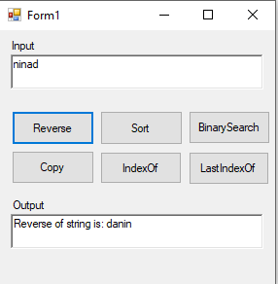 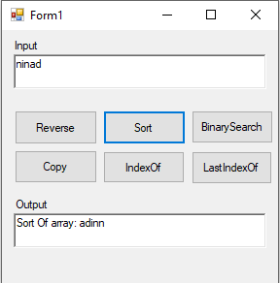

**Reverse** **Sort**

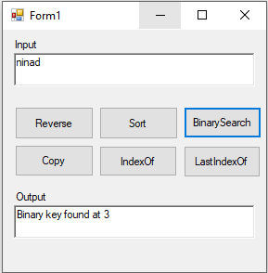 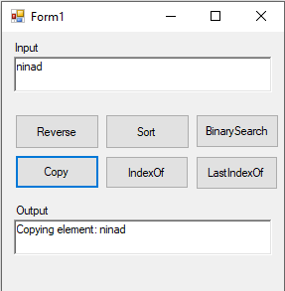

**BinarySearch** **Copy**

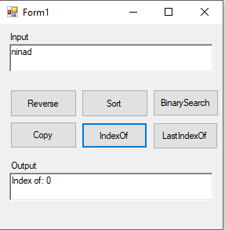 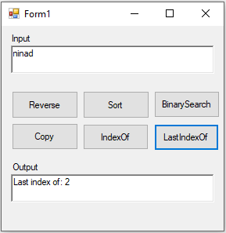

**IndexOf** **LastIndexOf**